**Art Guide**

**GAM 200**

**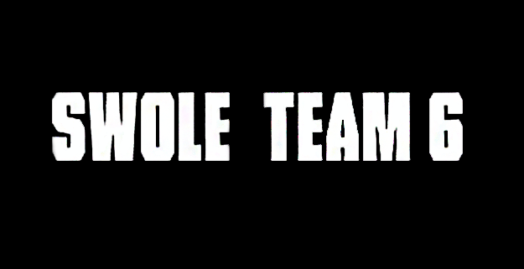**



# **ART OVERVIEW**

**Overarching Theme:**

NinjaCade is set in a Japanese-based setting that uses medieval Japanese theology, architecture, and warfare as inspiration for the varying environments players encounter throughout the game.

**Initial Art:**

When we began conception of the game’s art style, we used two base characters as reference for what we wanted the character art to feel like.

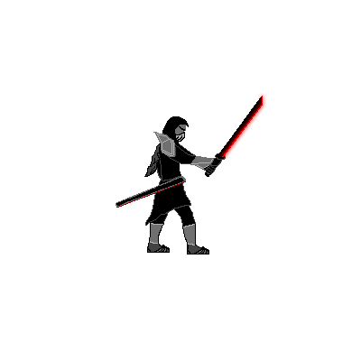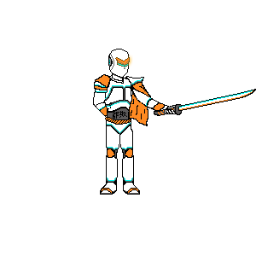-Zordra (player character) -Main Villain (nameless)

While the original concept was more of a cyber-punk/Tron look and feel for the players, our artists felt more inclined to work with traditional Japanese weapons and armor that would make animating easier for them to do while also keeping them interested in working on the project. Because of this, our final art style is strictly medieval in theme without LED highlighted technology.

# C:\Users\mitchell.regan\Desktop\tumblr_ms6vck2yiw1qeszi5o1_500_360.pngC:\Users\mitchell.regan\Desktop\statue_ref_5.jpg**ART REFERENCES**

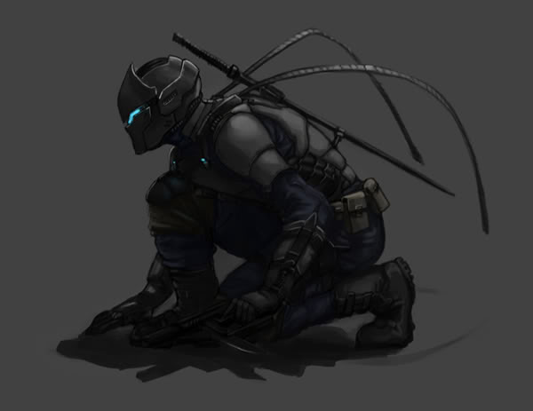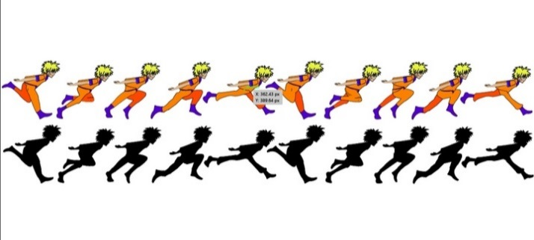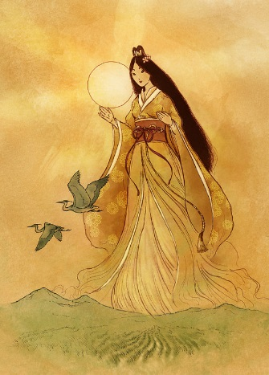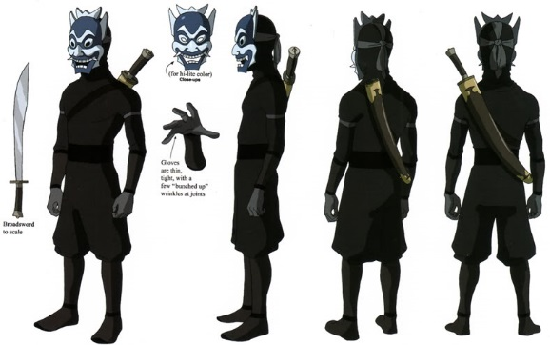

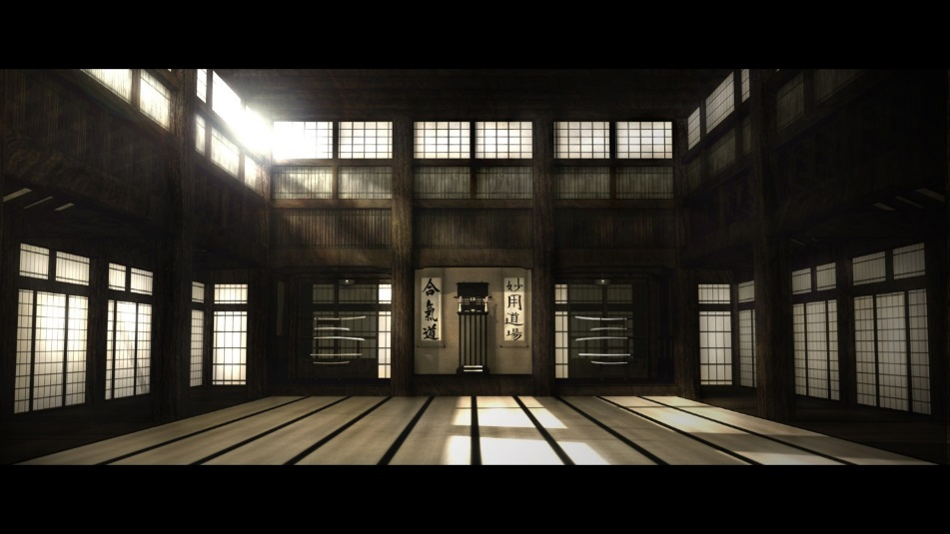

**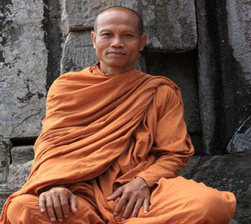**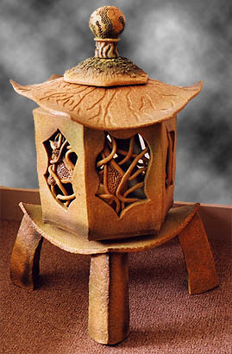

# **CONCEPT ART**

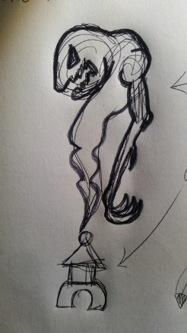**Enemies:**

* **Ulna & Rantan**: Below are Ulna & Ran-Tan, a possessed lantern that offers a cute innocent side of the enemy (Ran-Tan), while the evil that possesses the lantern (Ulna) is emitted in a smoke-like aura. The design behind the lantern came from several different iconic Japanese lantern builds that we took bits and pieces from in order to create Ran-Tan. Ulna is a demonic looking spirit embodied in the smoke that is emitted from the fiery lantern. The smoke takes a physical form and attacks the player with its large claws and arms while also having the ability to abuse Ran-Tan’s fire to burn enemies.

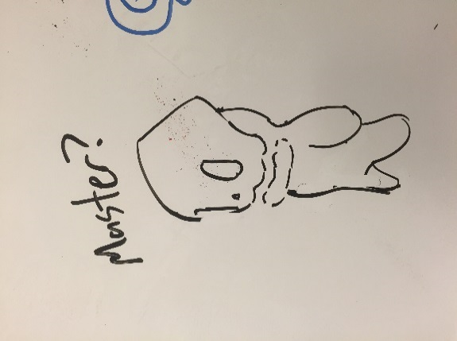

* **Kutsu**: The Kutsu is based off of the idea that children’s souls are lost within the forest and roam freely with only ties to their mother’s spirit.
* **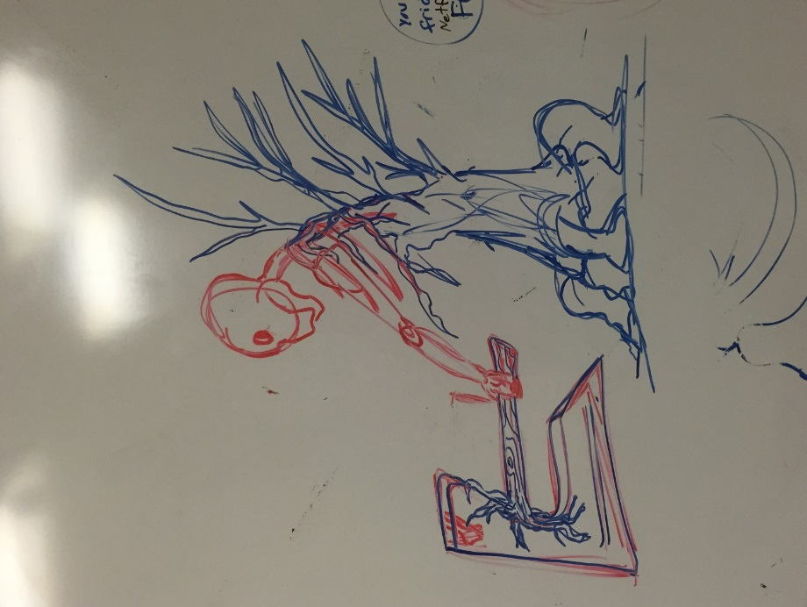Mother**: The mother of the children’s spirits. This monstrosity is highly defensive of her territory and uses a woodcutting axe to slaughter those that oppose her or her children. We wanted to create a very slow, hulking, mob-spawning enemy that the mobs would come from when this enemy was aggravated. We used a tree base as embodiment of the spirit so that the small mobs could hang onto the spirit for the ride while also giving the forest a more dramatic theme. The presence of the character should cause an intense if not frightening engagement for the player as the appearance of these rare monsters is rare and monstrous.

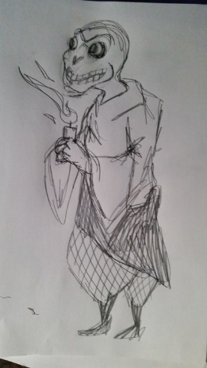

* **Possessed Monk**: Originally, these characters were peaceful monks who inhabited the temple of the Sun Goddess. However, when the temple was taken over by an evil entity, the monks were taken over and transformed into powerful warriors. These enemies would be “heavies” for the player to fight in the last levels of the game, occasionally mixed in with larger groups of fodder enemies.

**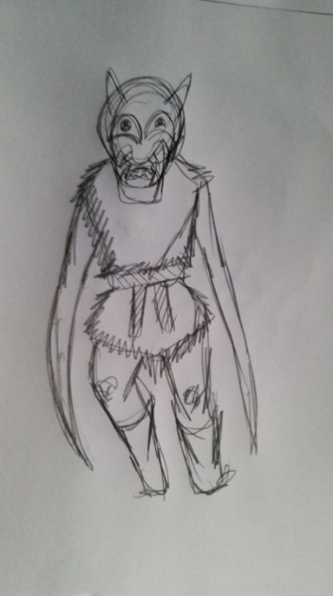**

* **Scarecrow**: Creepy straw-men dressed with ragged clothes, demon mask, and scythes for arms. This enemy is intended to be weak but agile fighters that focus on hit-and-run tactics while staying out of direct combat with the player so that they’re more of a nuisance that catches the player off guard.
* 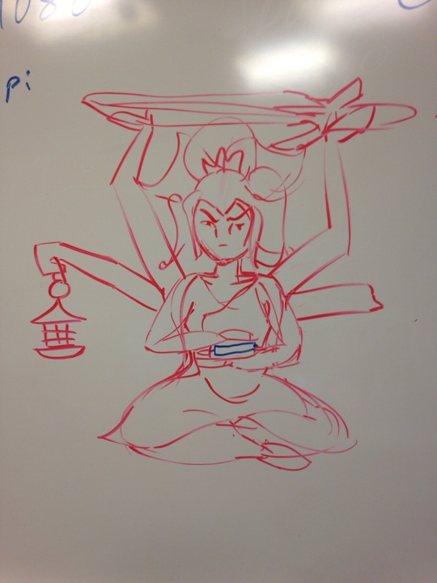**Sun Goddess**: A hybrid of Kali, the Hindu Goddess of Destruction and Amaterasu, the Shinto Goddess of the Sun, this 6-armed, Kimono-clad enemy is the final boss of Ninjacade. While not the actual goddess, the player will have to fight a giant stone shrine in the shape of the Sun Goddess to stop the evil spirits spreading from the temple. She fights the player by swinging her stone sword and casting fire spells with her lantern. She will also be very slow and impactful with all of her movements since she’ll be so large compared to the player, making for a grander, epic last encounter to the game.

# C:\Users\mitchell.regan\Documents\swole_team_6\GAM200_Project\resources\Textures\Source\Anitmaed\Character_4.png**FINAL ART**

* Idle Animation
* Run Animation

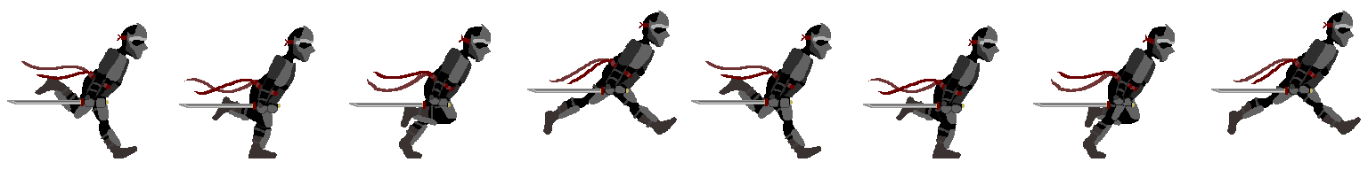

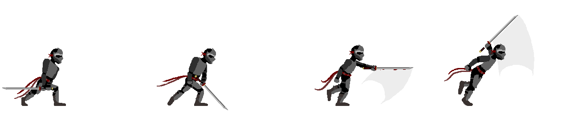

* Slash Attack Animation
* 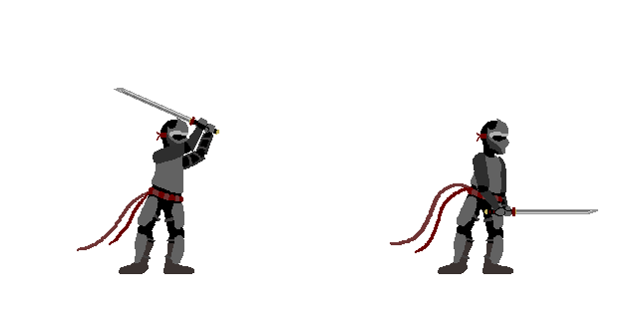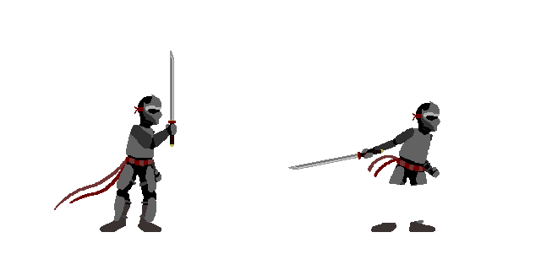Basic Attack Animations
* 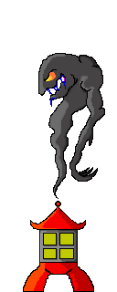Ulna & Rantan Enemy
* Level 1 Tile Map (Japanese Buildings)

